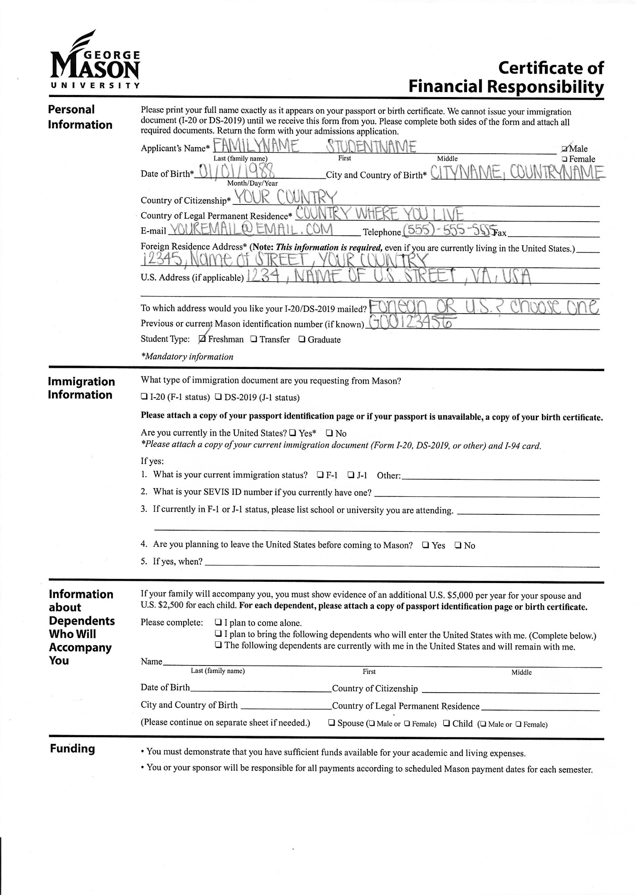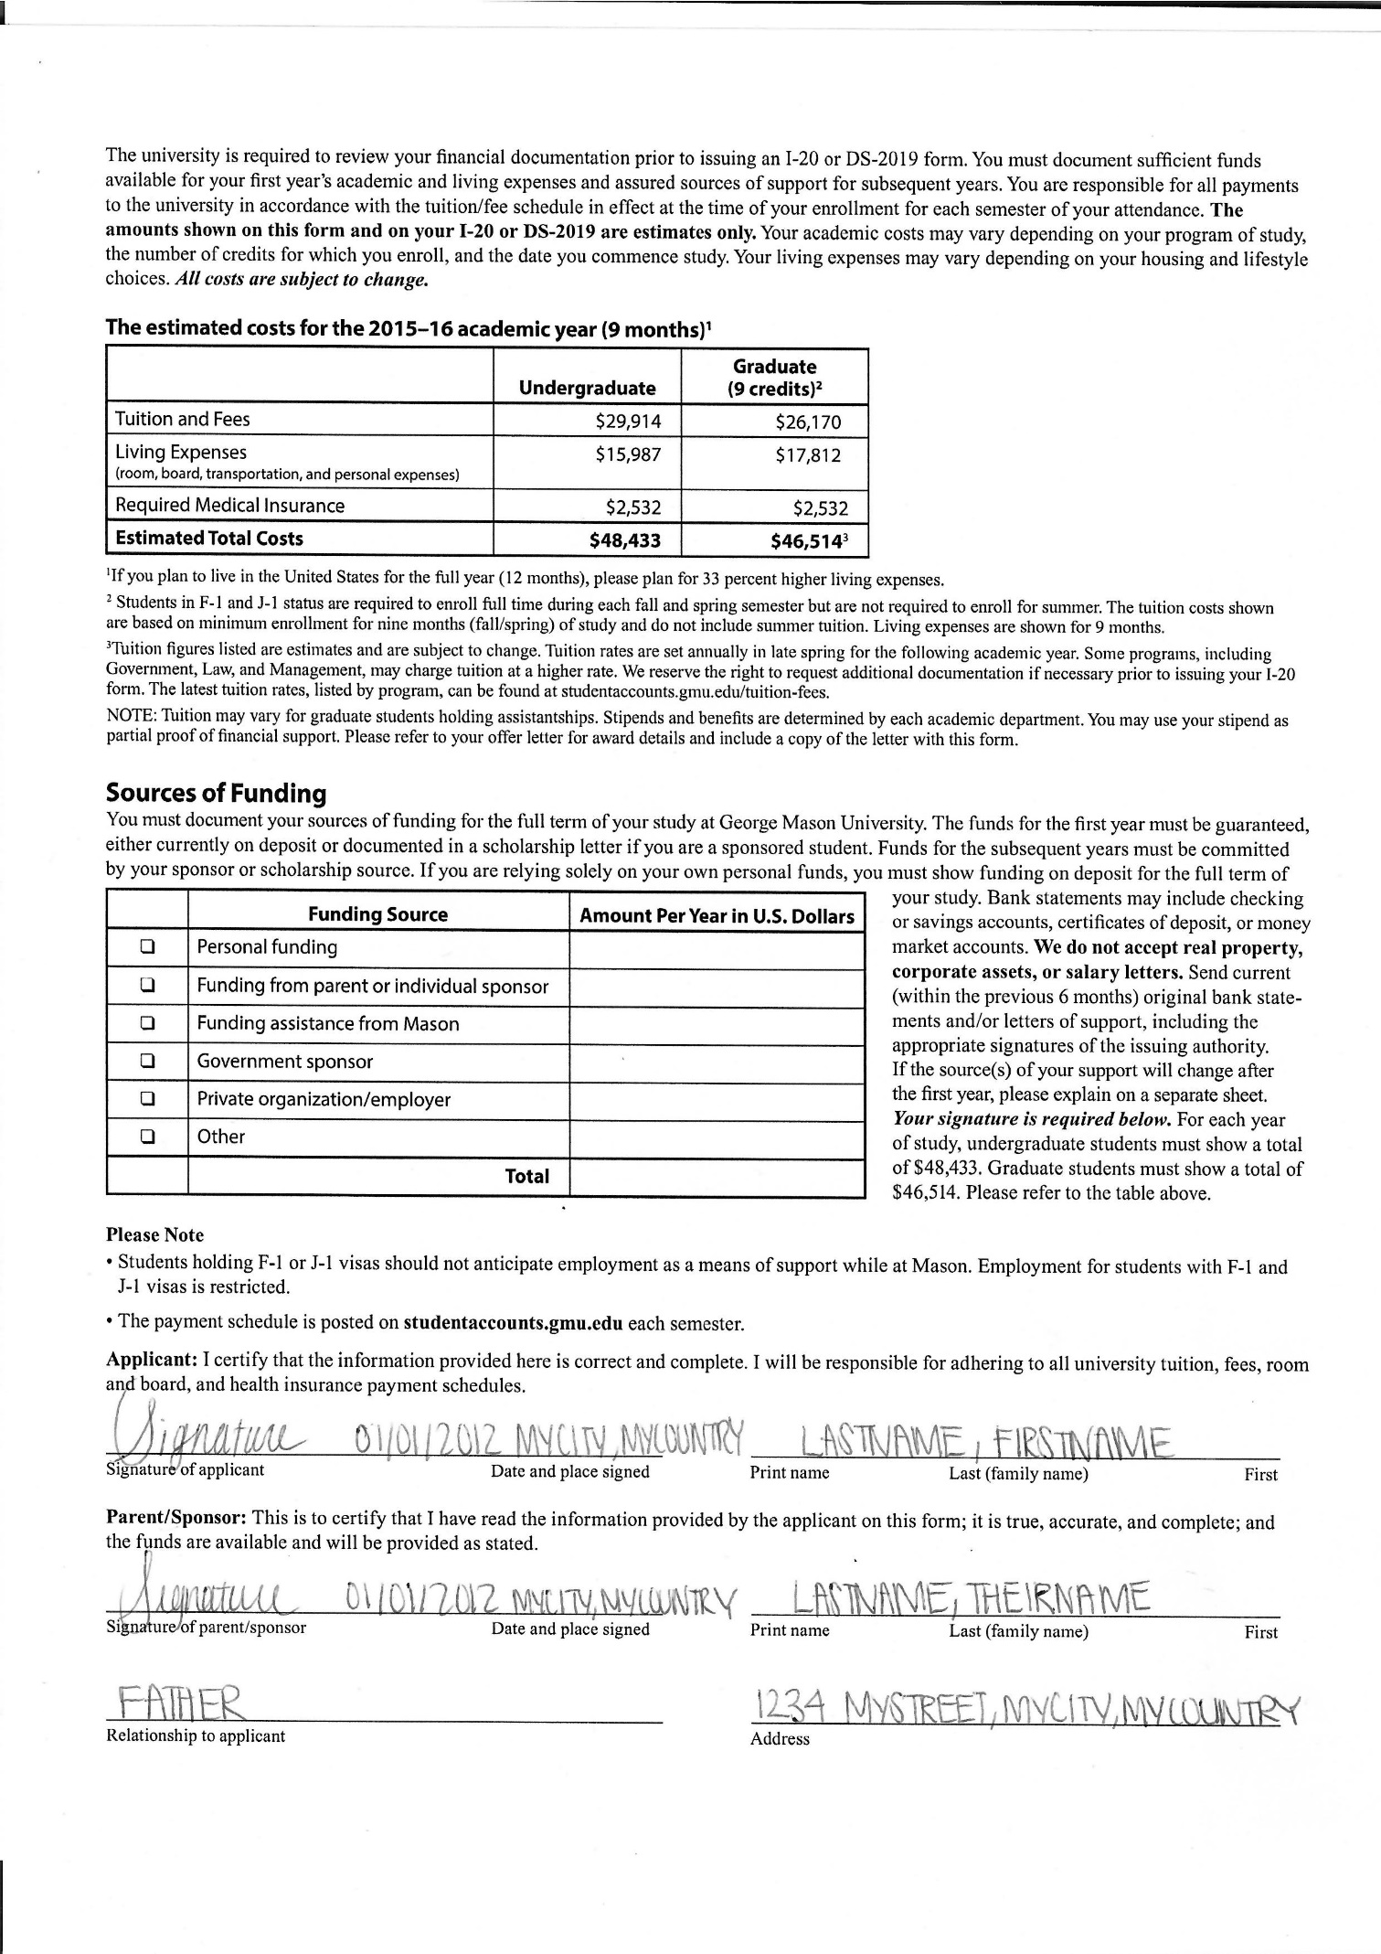

**NOTE: Foreign Address is required!**

Make sure to check one

If you have attended or are currently attending a U.S. university, you MUST fill out this section.

Don’t forget to check one of these boxes

Fill in your Personal information here:

You MUST include information for all family members.

This is funding in the name of your sponsor and must show sufficient funds for **one year**.

Sign

Print your name (and your Parent or sponsor’s name)

This section only needs to be signed and filled out if you have a funding sponsor. The sponsor’s name must match the financial documents submitted.

Must be on **official letter-head** and signed by CFO

Must be on **official letterhead and list GMU as the attending university**

This must be on **official letter-head and signed by a department official. (GTA or GRA)**

This is funding in the name of the student and must show sufficient funding for **one year**.